http://hsu.ciss.org.cn/Student_Services/4919

International students are suggested to open a Chinese bank account when they arrive the university. In China, some universities will help international students open bank accounts so that students dont worry about this; while in most cases, universities require students to open Chinese bank account themselves and hence its necessary for you to get the knowledge of how to open bank account in China. Here are some tips for your reference.

The Currency of China
Rénmínbì is the official currency of China. It is abbreviated as RMB, and the unit of Renminbi is yuán, Jiao and Fen. 1 yuan equals 10 jiao while 1 jiao equals 10 fen. The fen is rarely used nowadays. RMB is issued in the following denominations: one, five, ten, twenty, fifty and one hundred yuan; one, two and five jiao. Fen has almost disappeared, so the coins in circulation are one yuan, five jiao, and one jiao. Banknotes range from one yuan to one hundred yuan, and vary both in size and color. Currently, yuan is the base unit of RMB. It is used to denominate bills, and is the unit in which prices are measured. Local Chinese always use qián to refer money same way as American use bucks to mean dollars.
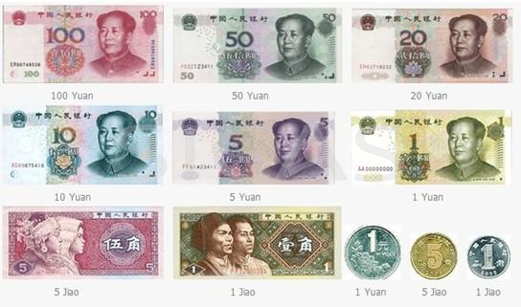
1. Where to open a Chinese bank account?
Generally foreigners can easily open a bank account in a Chinese bank. There are many Chinese banks in China, such as Bank of China, Agricultural Bank of China, Industrial and Commercial Bank of China, China Construction Bank,China Development Bank and so on. You can open a Chinese bank account in any ofthese Chinese banks. The largest four banks in China are Bank of China, Agricultural Bank of China, Industrial and Commercial Bank of China and China Construction Bank, which have many branch banks spread in different cities of China, so we strongly recommend students to open the bank account in one of these four banks. The relevant websites are listed in the end of this article.

Bank of China is the most internationalized and diversified bank in China and it provides full range offinancial services in China's mainland, Hong Kong, Macau and other 31countries, therefore, this bank that helps you wire money overseas might be your preferred bank. Its ways to contact overseas branches are also listed in the end.

2. How to open a bank account?
The procedure of opening a bank account is stated below:
Step 1
Before you enter into the bank, you should prepare some materials. One necessary document you need to bring with is your valid passport,but in some cases, a residence permit is also needed.

Step 2
After you enter into the bank, you can ask the bank receptionist for help and they will guide you with the procedure of opening the bank account. They will ask you for the documents that are needed and help you print these materials. In most banks, the print is free of charge but in somebanks, you will be charged five Jiao or one Yuan.

Step 3
After that, you will be given a form to fill in. Usually,there is a reference form presented on the clerk desk. You can take this form for reference and if you have any questions, you can ask the bank receptionist for help.

Step 4
With the printed materials and filled form, you should then get a queue number from the Automatic Number Machine and wait on thewaiting desk (Sometimes if there are too many people are waiting in the bank,you can also get this number when you enter the bank and then do other things that mentioned in the above to save time). Please pay attention to the broadcastand electronic screen while waiting there.

Step 5
Its your turn to deal with your business when your number is called. You should only give your printed materials and filled form to the banker who will help you open the bank account. To open a Chinese RMB account, you have to pay a deposit of 10-15 Yuan in most banks but the charge may be different in different banks.

After you have gone through all these steps, you will be given a debit card or a bank book. With this card or book, you can deposit or withdraw money, exchange currencies and wire money overseas.

THE Largest Banks in China
Bank of China
Website: http://www.boc.cn/en/index.html
Agricultural Bank of China
Website: http://www.abchina.com/en/default.htm
Industrial and Commercial Bank of China
Website: http://www.icbc.com.cn/icbc/sy/default.htm
China Construction Bank
Website: http://www.ccb.com/en/home/index.html

Overseas Branches of Bank of China
In theAsia-Pacific Region
Website: http://www.boc.cn/aboutboc/ab6/200812/t20081211_143775.html
In the European Region
Website:http://www.boc.cn/aboutboc/ab6/200812/t20081211_143776.html
In the Region of the Americas
Website:http://www.boc.cn/aboutboc/ab6/200812/t20081211_143777.html
In the African Region
Website: http://www.boc.cn/aboutboc/ab6/200812/t20081211_143778.html

