Wuchang University of Technology (WUT) is a private university for higher education approved by the Ministry of Education. After twenty years of development, it has become multi-disciplinary in harmonious development where management and engineering are core disciplines.
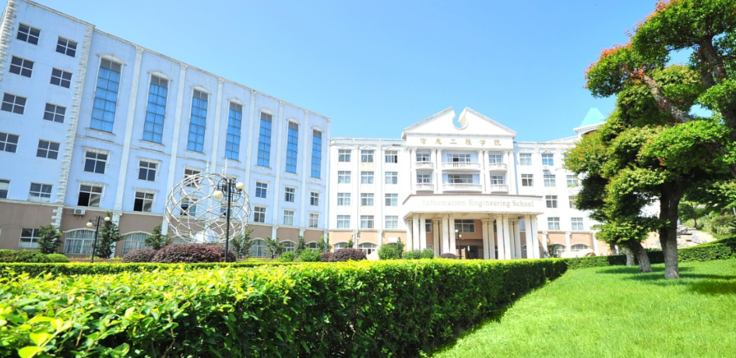
Situated in "Optics Valley of China" in the southeast part of Wuhan in Central China's Hubei province, WUT covers an area of about 233 acres with a construction area of over 400,000 square meters (about 100 acres). It is known as one of the top ten beautiful lake campuses in China. It is at the foothill of Mt. Meinan. Three sides are surrounded by Tangxun Lake. And on the campus, European-style buildings nestle among the trees.
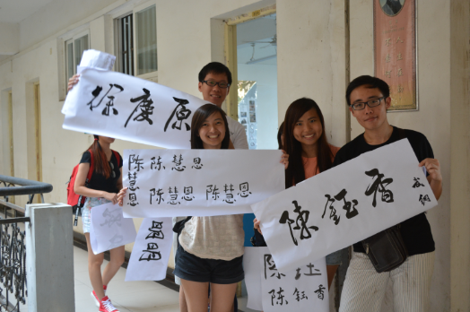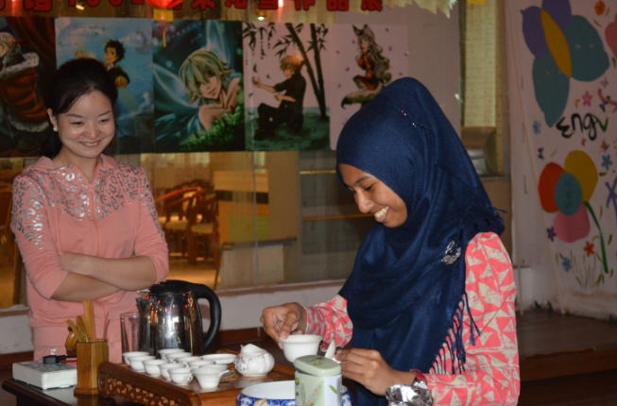
WUT has eleven schools which contain altogether 65 disciplines (4-year programs or 3-year programs). The schools are School of Life Science, School of Information Engineering, School of Urban Construction, School of Business, School of Law, Literature and Foreign Languages, School of Art Design, School of Music and Media, School of International Education, School of Non-specialized Caliber Education, School of Continuing Education, and School of Autonomous Study and Examination. At present, there are over 15,000 students.
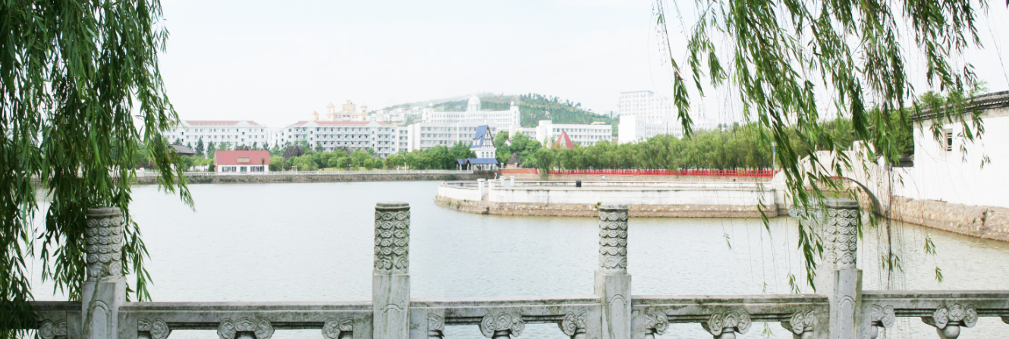
Now there are over 1,000 staff in WUT, among whom 730 are teachers -- 138 professors, 186 associate professors, 46 doctoral tutors, 87 master instructors, and 18 state-level experts.

There is an A-level library with an area of 35,000 square meters. Now, there are in the library over 1,400,000 volumes, over 760,000 volumes of e-books, and over 1,400 domestic and foreign newspapers and periodicals.

There are 138 laboratories, which can offer 2810 kinds of experiment on campus. And there are 181 stable training bases inside and outside WUT for the students' internships and training.

WUT is well-equipped with many kinds of facilities, including an academic centre, a stadium, a club, a gym, a student service centre, a student activity centre, a 3D cinema, standardized students' apartments and dining halls, financial service networks, a hospital, and supermarkets.

WUT has originated a personnel training mode, Caliber-oriented Education to Success. It has won the second prize of the 6th National Teaching Achievement, the only private university among the winners. In 2010, it was listed as a pilot university on national reform of educational system by the State Council, the only university of its kind to launch a pilot comprehensive project on national educational reform.

WUT has made great achievements in high-caliber personnel training, and it’s among the top private universities in education and management. The employment rate of its graduates has reached more than 92% over the past years. In 2014, it was ranked No. 1 among all provincial universities in Hubei province, and over 18% of the seniors have passed the examinations for civil servants and postgraduate students; nearly 30% of the graduates have worked in large domestic enterprises or in the world top 500 companies.
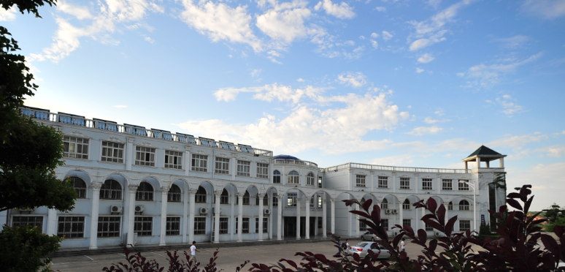
WUT tops China’s other private universities in discipline construction. "Bioengineering" is a provincial key discipline. "Bio-peptide Diabetes Drug Research" has been approved as a provincial collaborative innovation center. In Hubei Province, it is the only one possessing an approved Key Research Base on Humanities and Social Sciences ---- "Students' Caliber Education Center in Private Universities". School of Life Science is the only pilot school in Hubei. It boasts 17 approved key specialties and excellent courses at provincial level. In 2014, it was awarded Entrepreneurship Demonstration Base.

WUT, by international development strategy, is quite fruitful in international communication and cooperation. With universities in more than ten countries like USA, UK, Australia, Russia, Italy, Japan, Korea, and Singapore, Thailand, and India, WUT has established cooperative relationship to provide a full range of services for the students' paid internship as well as further study and tour abroad.

WUT has won various prizes, such as "China's Top 100 Universities in Graduates' Employment Competitiveness", "China’s Top Ten Competitive Brand in Private Universities", "China's Top Private Universities in Comprehensive Strength", "China's Top Ten Private Universities in Influence". It was ranked No. 144 in the four-year-programme education in the list of China’s universities in 2012, one of the only two private universities.

All over the country, students are enrolled according to the local admission points on the basis of competitive selection. Students who attain required credits will get the graduation certification and those who are qualified for bachelor degree will be granted WUT diplomas. Meanwhile, they can work for a double major on campus. Among the same universities in Hubei, WUT took the lead in joint training of postgraduates with relevant universities. It also possesses a Top-up Program. Students with junior college diploma can obtain undergraduate diploma through examinations given by WUT.

