浙江师范大学本科留学生转专业申请表
Application for Program Change for International Undergraduate Students in ZJNU

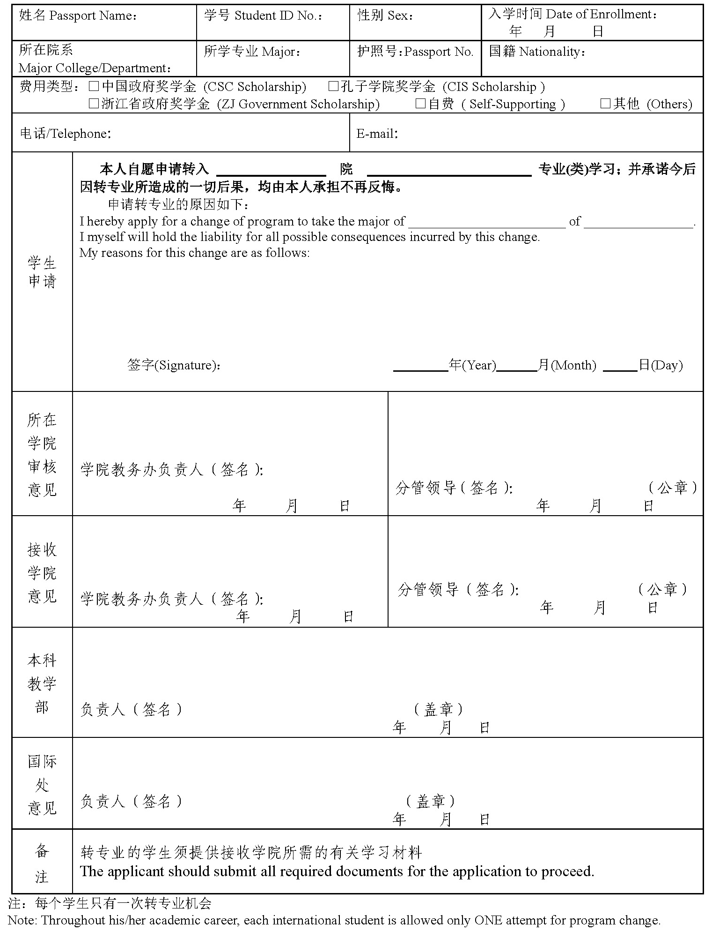

浙江师范大学研究生留学生转专业审批表
Application for Program Change for International Graduate Students in ZJNU
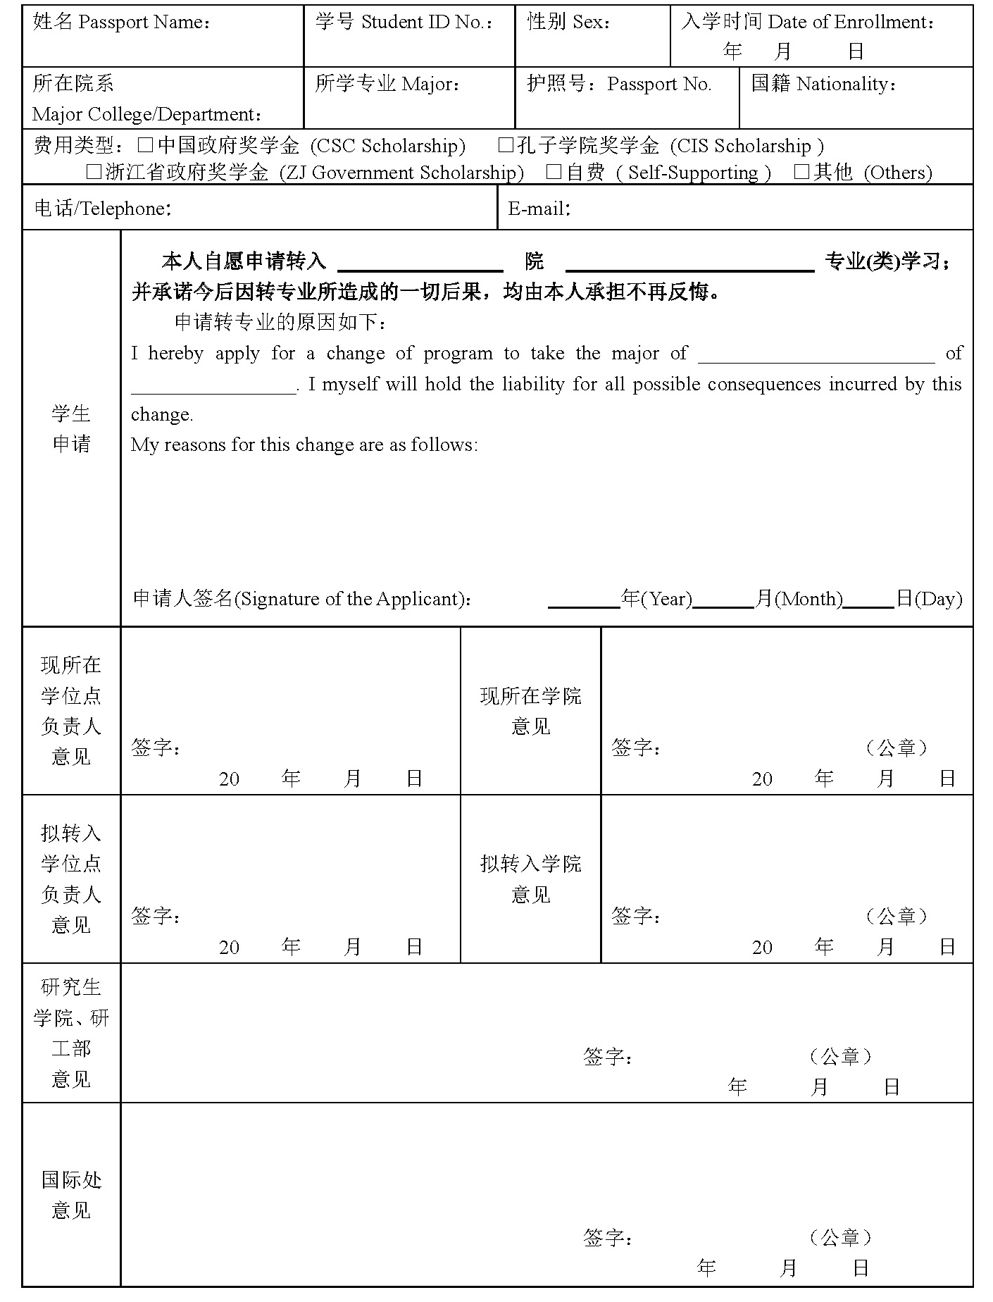
注(Notes)：
每位学生在读期间只有一次转专业机会。(Throughout his/her academic career, each international student is allowed only ONE attempt for program change.)

